SEMI CIO and MIO Configuration Readme

CIO and MIO need to be installed. For Installation, please refer to the Opcenter Execution Core
System Administration Guide and Manufacturing Interoperability User Guide.

CIO Configuration
There are few CIO modeling data that need to be loaded into the system. Execute the spreadsheet located at C:\Program Files (x86)\Camstar\SEMI XLS Import\SEMI 0050 CIO Controls.xlsm to load the required modeling data. Copy the xslt file from C:\Program Files (x86)\Camstar\SEMI CIO\XSLT\scsMapDataMap.xslt to C:\CIO_WEB\Broker\PlugIns\scsMapDataMap.xslt. (This is the default location of the xslt file, make sure that it points to the correct path.)

MIO Configuration
There are MIO Adapters and MIO Configurations that need to be configured for SEMI features. Locate the Config file of Opcenter Execution Core Transaction Tester at C:\Program Files (x86)\Camstar\SEMI CIO\CTT\SS MIO Configuration.cfg

MIO Map Designer
Map Data Visualization requires MIO Message Maps to be imported.
To import the MIO Maps:
- Open MIO Map Designer.
- Configure the MIO Server Settings tab if you have not done so.
- Click the button shown below.
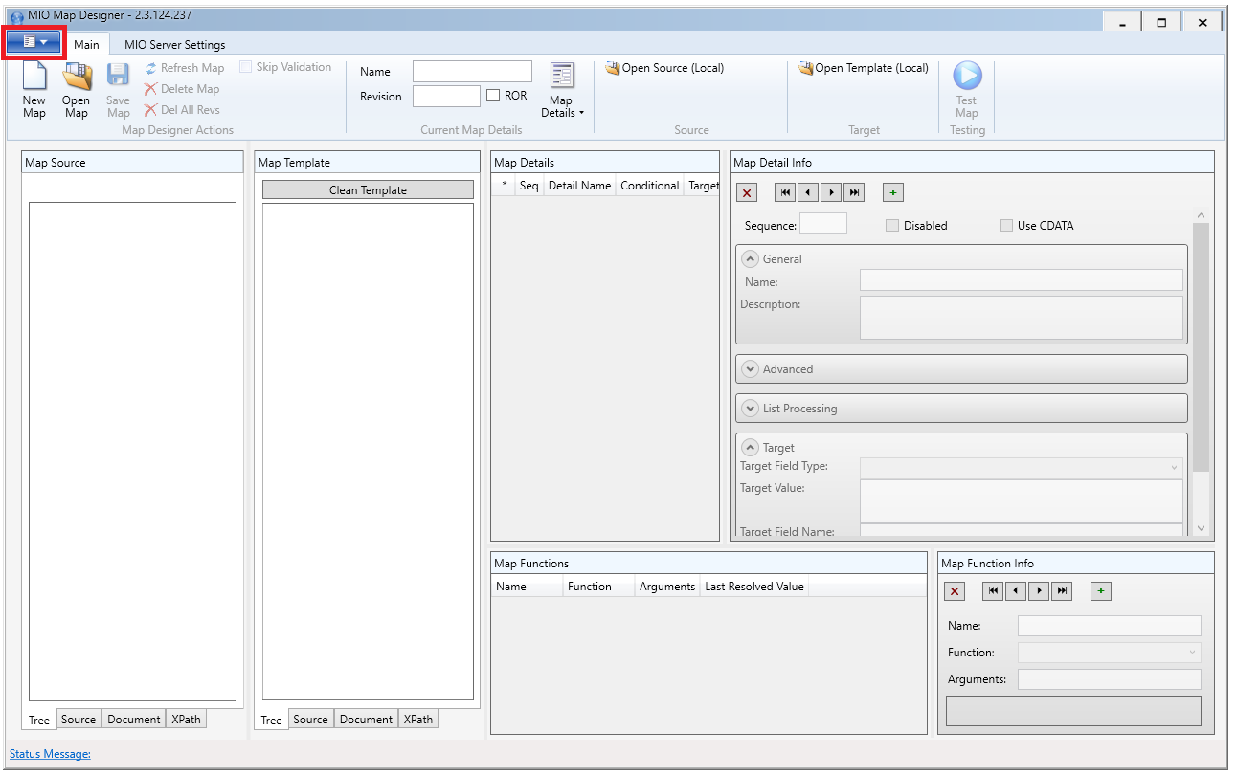
- Click the Import Map button.
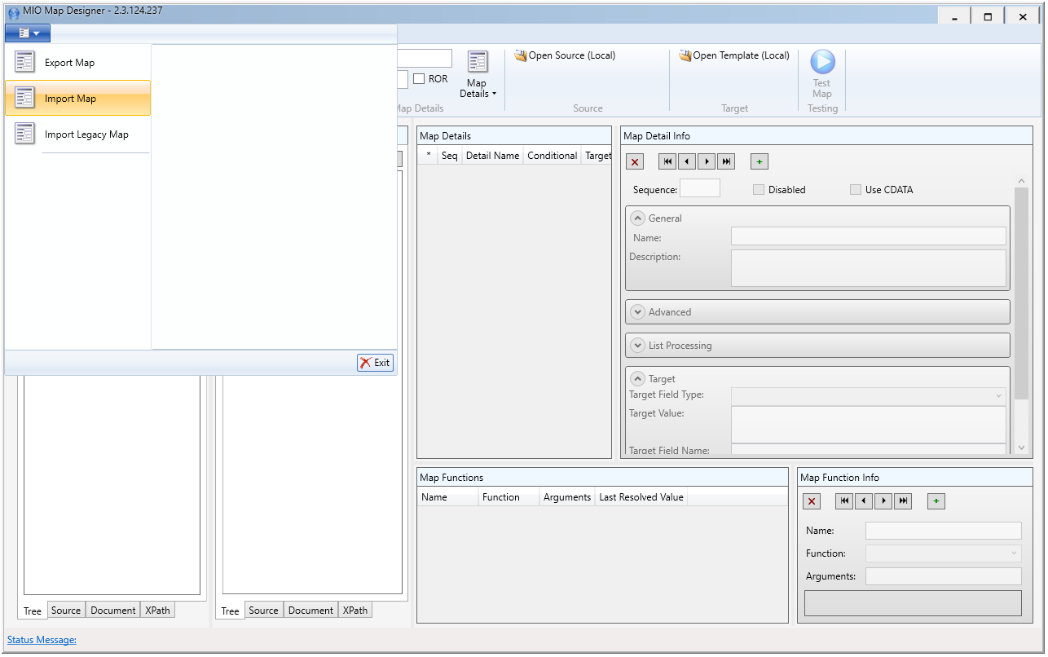
- Select the map files (.miom) from C:\Program Files (x86)\Camstar\SEMI CIO\Maps.
- Click the Save Map button.

